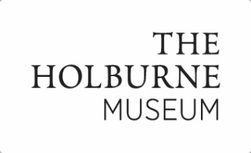
Art Camp Consent form 2016

Name of Child/Children:

Date/s of Birth:
Parent Name:
Person/s to Drop-off/Collect Child:
(if different)
Parent Address:
Emergency Contact Name/No 1:
Emergency Contact Name/No 2:
Home Tel No (if different):
Email:
Allergies/phobias/known reactions to art materials/Medication Details:

Does your child have any special needs (physical, learning or emotional)?

Continued…..

Please read each of the following statements and for yes or X for no or write yes or no in each box.

I agree to my child and/or their artwork being photographed or filmed for publicity purposes (e.g. Museum website, What’s On Brochure, Pinterest and other publicity media);
Please note: Children’s names will not be used

I consent to any emergency medical treatment necessary for my child/children during the workshop.

If applicable, I agree that I will supply a letter of authorisation to administer non-emergency medication that I will supply for my child.

I confirm that I, or a designated person, will accompany and sign in my child/children to the workshop and collect them promptly afterwards and sign them out.

I confirm that I have read and agree to the terms and conditions supplied with my booking confirmation

I confirm that my child is over the age of 5.

Print Name:

Signed (Parent/Guardian) – typed signature is acceptable:

