Late Spring Bank Holiday Art Camps |  | 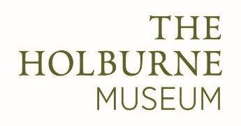
Tuesday 29 May | Lucia Harley | Food Feast  Create everything set for a feast:  dip cast crockery, weave a colourful rag-rug mat. Print cutlery and food for the table based on our exhibition ‘Made for the Table’.
Wednesday 30 May | Mary Caron Courtney | Fanciful Flights  Using the museum’s wonderful bird imagery, create a fabric hanging depicting drawings of our feathered friends. Use fabric paints, collage and a variety of embellishments to create a very special bespoke work.
Thursday 31 May | Mary Caron Courtney | Still Life Here and Now  Inspiration will flow when you visit the Prized Possessions exhibition. You will focus on the Still Life images and then create a 3D contemporary model of your own in response to your observations using junk, collage and paint.
Friday 1 June | Suzi Symons | Hoist the Mainsail  Create billowing sails for a 17th Century Dutch tall ship. Explore playful ways to apply paint, dripping, blowing and splattering, producing surfaces inspired by the sea and sky. After gathering interesting patterns and shapes in the gallery, you will use print and collage techniques to produce a beautiful sketch book using navigation charts.

