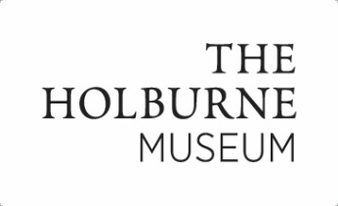
Art Camp consent form 2019
Name of Child/Children:
Date/s of Birth:
Parent Name:
Person/s to Drop-off/Collect Child:
(if different)
Parent Address:
Emergency Contact Name/No 1:
Emergency Contact Name/No 2:
Home Tel No (if different):
Email:
Allergies/phobias/known reactions to art materials/Medication Details: | All parents/carers - please see ‘Important Information for Parents’ re our request to exclude nuts from lunchboxes.
Does your child have any special needs (physical, learning or emotional)?

Please read each of the following statements, and mark with a cross your chosen box. Please complete both pages. | Yes | No
I agree to my child and/or their artwork being photographed or filmed for the promotion of Holburne Museum activities (e.g. website, E-newsletter, annual reviews)
Please note: Children’s names will not be used
I consent to any emergency or non-emergency medical treatment necessary for my child/children during the workshop.
I am supplying my child with medication for them to take/administer themselves (or see below)
I am supplying my child with medication and agree to a member of the Holburne staff administering it as instructed by me in writing.
I confirm that I, or a designated person, will accompany and sign in my child/children to the workshop and collect them promptly afterwards and sign them out.
I confirm that I have read and agree to the Important Information for Parents supplied with my booking confirmation.
I confirm my child is over the age of 5.
I agree that the Holburne cannot take responsibility for my child on their journey to and from the Museum if they intend to arrive and leave unaccompanied by me.
Please can you tell us how you heard about the Art Camp?

Print name:
Signed (Parent/Guardian) typed signature is acceptable: | Date:

