Georgian Fans - Creative Activity 1:
Decorate a paper fan exploring some of these ideas:
Use colour pencils, pens, collage materials and ribbon and a bead to create a tassel which hangs down
Outside surface:
What I want people to know about me
The things I like and am interested in
How I’d like to be seen by other people
My hopes for the future
The things I’m proud of our …

Inside surface: (using invisible ink pens where you can only read the writing with a light or secret notes stuck face-down)
Something surprising about me that people don’t know
Some messages to myself – motivational!
My hopes for the future/ things I want to leave behind and change

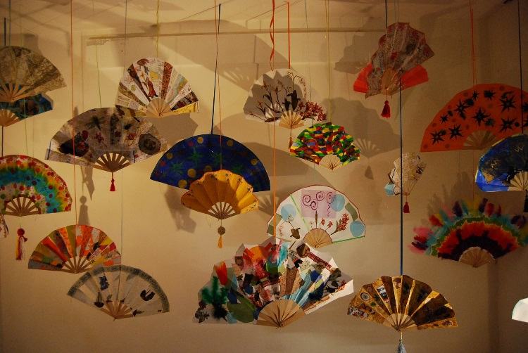

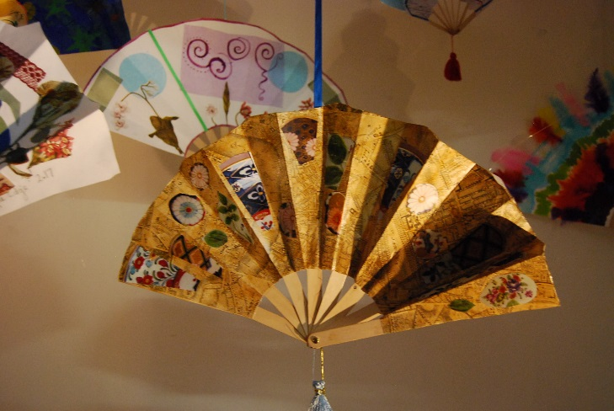

Hanging fans: Inspiration for how you could display your fans (from a project at the Holburne Museum

Georgian Fans - Creative Activity 2:
Decorate a paper fan with a story of an ‘allegorical’ journey (e.g., coming back to school after lockdown, moving up to the next year or moving to secondary school etc.) which runs from one side to the other. Children could use writing and images to create their personal story.
Middle of fan … your journey across the sea/ mountains etc.
the rocks/ storms/ sea monsters that represent the challenges/things you are worried about/or have to overcome

Start with left hand-side of fan
Where you are now …
your age/ where you go to school, possibly the things that you are leaving behind or want to change

Right hand-side
The place you are trying to reach … the goal or outcome you want, your hopes and ambitions for the future
Could be shown as a coastline or island

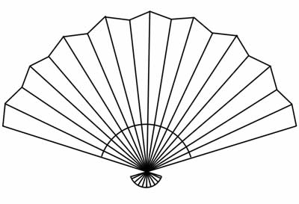

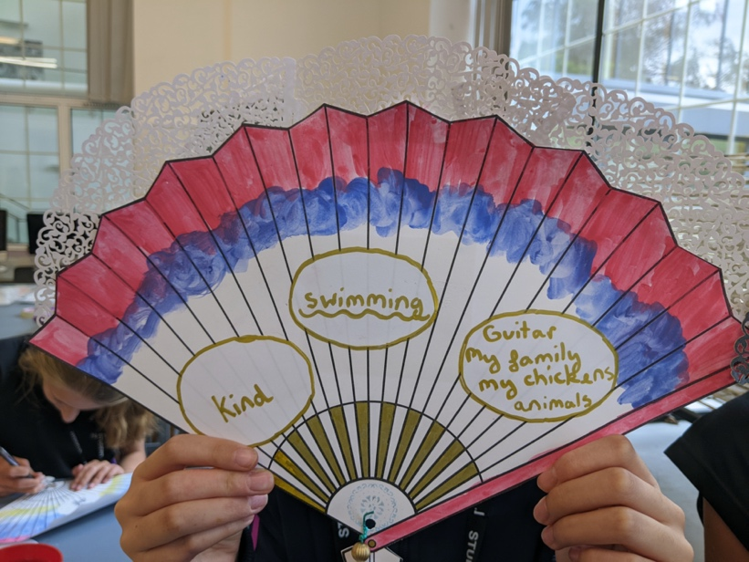
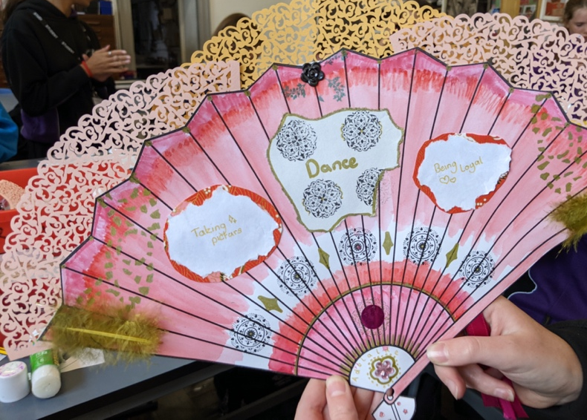
Examples of Georgian inspired fans made in a school outreach session
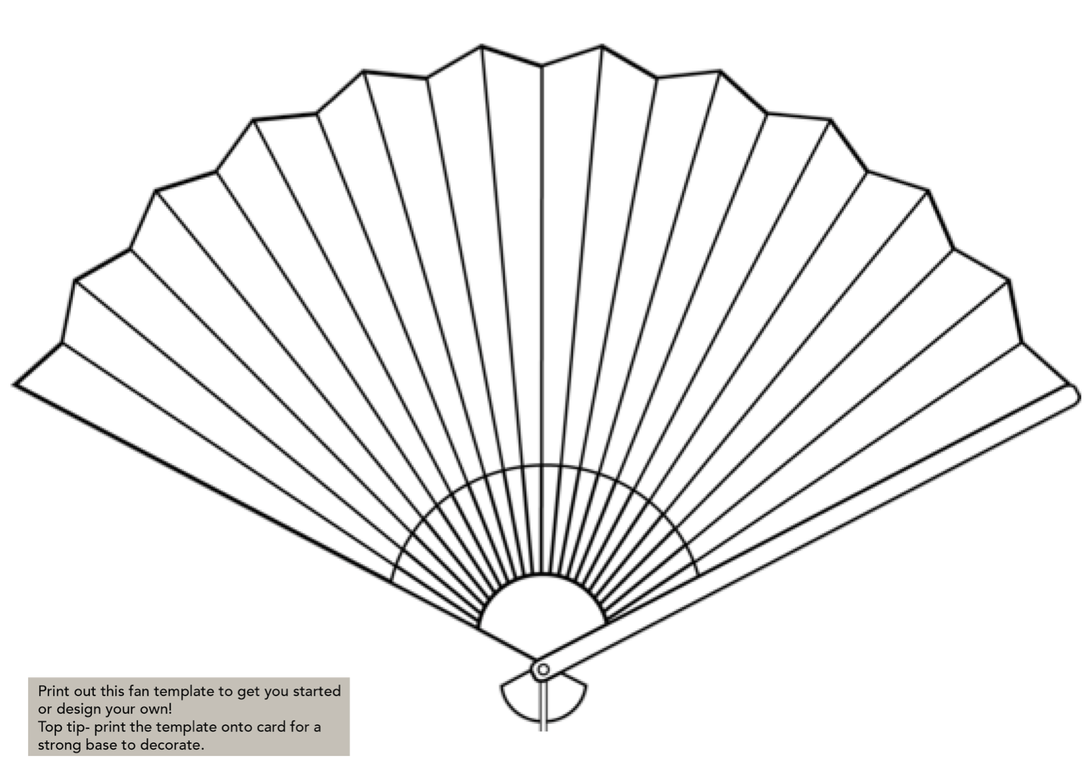

Creative Activity: Make yourself a Self-Care kit
Etui -
“A small ornamental case for holding needles, cosmetics and other articles ”
Use the idea of William Holburne’s ‘etui’.

Make a small ‘self-help’ receptacle that can be
beautifully decorated on the outside.
Use collage, buttons, gold paper, lace to
decorate.

This could be a ‘grooming set’ with card outlines of ‘objects’ which could be written onto.

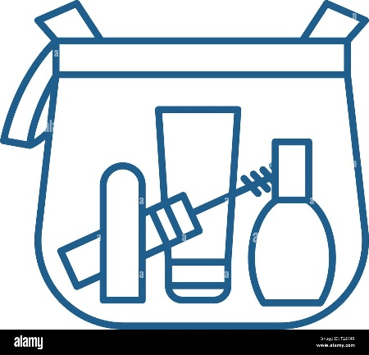
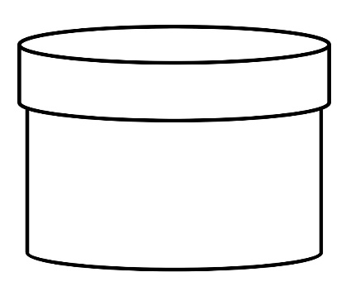

Small cards can be stored inside with writing about the following:
- Name 3 things that make you feel happy/ content/ positive when you’re doing them (or afterwards)?
- Write down a noise/ smell/ memory that makes you feel calm
- Where are the places you feel most safe?
- Choose a colour/ pattern/ words that you like
- Other ‘self-soothe’ sensory things could be added e.g., a piece of material you like the feel of

