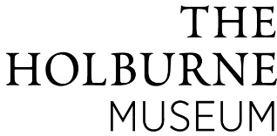
Unlocking Conversations – Provocations and Conversation Starters

Georgian Fans: Reveal and conceal

Provocation 1
- Hold the fan in front of your face so that only your eyes show.
‘Can you tell if someone is smiling or frowning?’

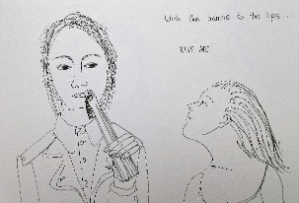
- Fans can be used to hide or show your face. You can hide your feelings or communicate something secret to someone by the way you hold your fan.

Practice using the language of the fan – what am I saying?

- Use Georgian fans to talk about what we choose to share about ourselves:
‘the public/ social media face’ (the outside of the fan)
vs.
what we may feel inside or want to keep private
(the inner side of the fan that only we can see when opened)

The 2 sides could also be used to discuss what information is safe and appropriate to share with others and when it’s important to share our worries or fears and ask for help from people we trust.

Georgian Fans: Overcoming challenges and exploring difficult transitions

Provocation 2
Use images of another fan in the Holburne ’s collection.
Allegorical Map of the Track of Youth, to the Land of Knowledge

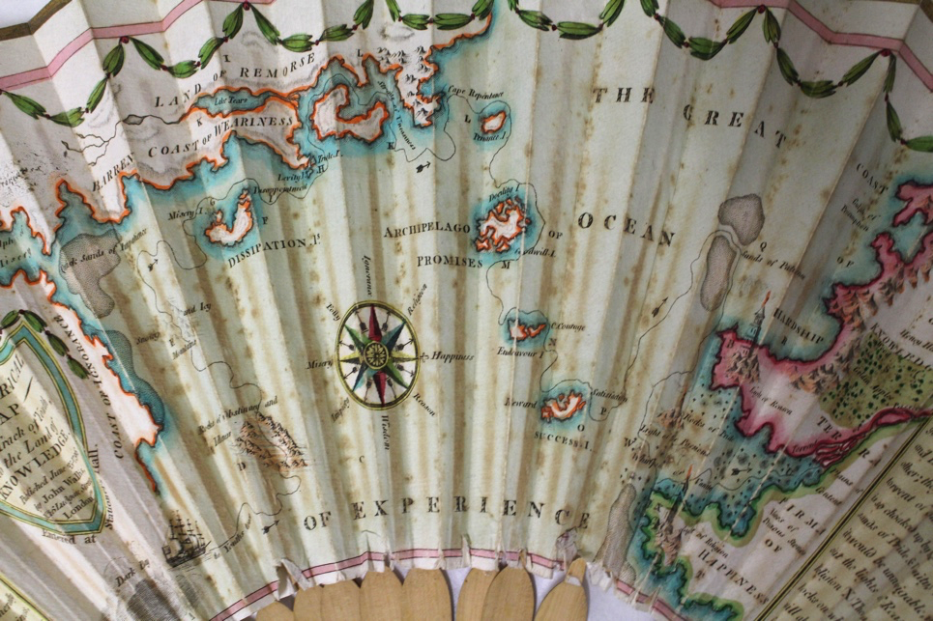
This is a folding paper fan which would have been sold as souvenir. It has a printed image on it (which has been hand-coloured) and tells an allegorical story of a person’s journey from youth (on the left) to experience (on the right).
(London: John Wallis, no. 16 Ludgate Street, June 25, 1796).
Engraved by Vincent Woodthorpe (ca.1764-1822) with hand colouring, wood ribs, brass pin and ivory washer.

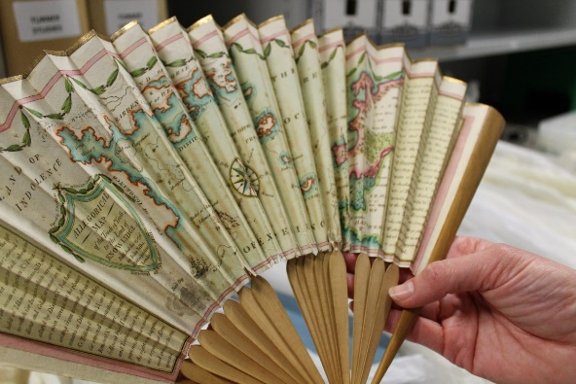
Examples to share and point out from this fan (or translate the ideas into different words):
- The Coast of ignorance
- Rocks of pride
- Rocks of obstinacy
- Barren coast of weariness
- An island of promises
- A light house of reason
- Terra Firma of happiness

Use the fan to explore how we cope with challenges or things that we need to ‘overcome’ using the idea of travelling from one place to another and the things we’ll need to help us on our way and build resilience.

Grooming in the 18th century - Thinking about Self-Care

Provocation
The objects in the loan’s boxes show us how Georgian people cared for their appearances – and kept up with the fashions of the day!
Big wigs, hair powder, patches (beauty spots), lavender scent and William Holburne’s ‘etui’ -a small ornamental case for holding needles, cosmetics, and other personal grooming articles.

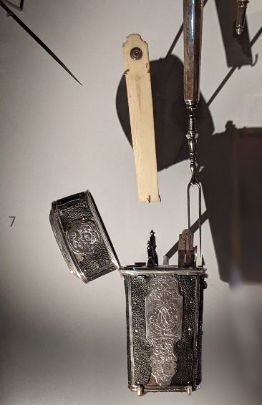
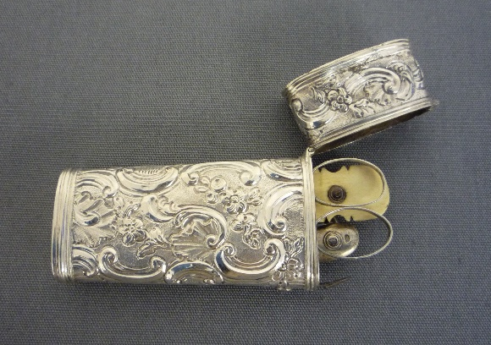
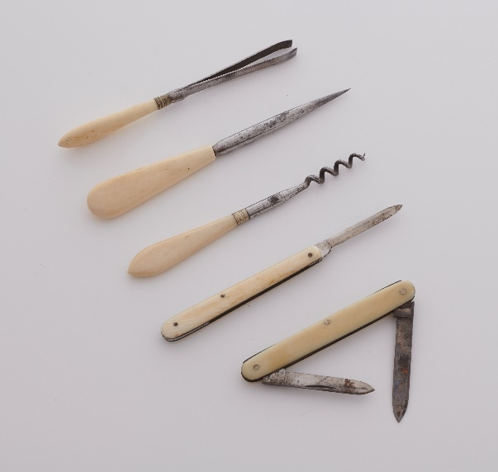
During the Georgian period in Britain wealthy men and women wore extreme amounts of makeup, with porcelain white faces and unblemished skin being the height of fashion. To achieve this look people painted their faces white with lead paint (even though it is poisonous!) and used ‘patches’ (fake beauty spots) made from leather, silk and velvet to cover up any smallpox scars and other problems with their skin.

Left: Some of the small personal grooming items and tools from the Holburne’s collection

Middle: Etui necessaire, silver, English, about 1760
Inside are an ivory writing tablet, steel scissors, pocketknife, scoop, and pincers

Right: William Holburne’s etui containing tiny silver and steel implements including knives, pincers, an ear scoop and an ivory writing tablet to write small notes on!
(This is exhibited in the galleries with the small objects surrounding it – you can see the dramatic lighting here)

Skip to the 21st century
Use the idea of grooming and caring about our outer appearance to start a discussion about how we look after our inner selves– how do we care for ourselves in terms of our feelings and mental wellbeing?

This is called self-care.

Part of this discussion could include the importance of children stopping to do a ‘check-in’ with themselves – paying attention to physical sensations, how their body is feeling (tense, relaxed) and noticing any repetitive thoughts or worries they may have.

